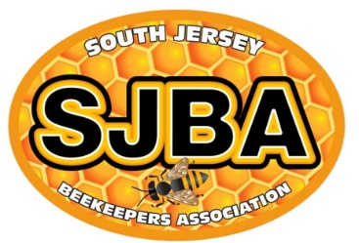
Basics of Beekeeping
by
South Jersey Beekeepers Association

“Basics of Beekeeping” is a beginning beekeeping course presented by the South Jersey Beekeepers Association (SJBA), a branch of the New Jersey Beekeepers Association. It occurs on Saturday March 7, 21 and April 4. The live classes run from 8:30AM to 12:30PM at the Camden County Sustainability Complex as well as available online via Zoom. The address of the complex is 508 Lakeland Rd, Blackwood. The cost is $125.

The core curriculum is suitable for adults and children 12 years and older who are new to beekeeping. It provides the basic information you will need to get started in honeybees and qualifies for the education requirements for new beekeepers under New Jersey beekeeping regulations (§2:24-3.1(c)6).

The textbook The Beekeeper’s Handbook, 5th edition by Sammartaro and Avitabile and electronic handouts are included in the registration fee.

Rob Dietrich, SJBA Education Chair, is the lead instructor for this course. Rob has been keeping bees since 2014 and has been a sideliner beekeeper since 2019. Contact: sjbaeducation@gmail.com

Important: Students must attend at least four of the six classes and must attend Class 4 to receive a Certificate of Completion.

Course Topics:
Class 1 03/07/2026 Becoming a Beekeeper; NJ Regulations, Honey Bee Biology
Class 2 03/07/2026 Hive Components, Tools, Protective Gear, Getting Bees
Class 3 03/21/2026 Setting Up an Apiary, Feeding
Class 4 03/21/2026 Pests and Diseases of Honey Bees Note: Mandatory Class
Class 5 04/04/2026 1st year and 2nd year Colony Management
Class 6 04/04/2026 Harvesting Honey

Along with the classes, field days will be held in March - April 2026 on Saturdays, after the class, time and weather permitting. During the field day, hives will be opened to show eggs, larvae, pupae, workers, drones, queen (maybe), brood pattern, how to light and use a smoker, and how to use a hive tool. Attendance at one field day is required to receive a certificate. There is an option to attend a field day with any of the New Jersey Beekeepers Association branches that must be validated by one of the local branch officers.

Scholarships: The New Jersey Beekeepers Association (NJBA) offers scholarships for students aged 12 to 21. Contact the NJBA Scholarship Committee at scholarship@njbeekeepers.org for more information. SJBA offers scholarships for students aged 12 to 21 as well as veterans and first responders. Contact the SJBA Scholarship Committee via email at sjbaeducation@gmail.com for more information and to request an application form.

The registration deadline is Saturday, February 28, 2026. Payment must be received by this date to allow time for the textbooks to be mailed and delivered before the first class.

